Understanding Color Assignment
Part I: Create 4 paired interaction color studies. Try to make 1 color appear as 2 different colors by altering its surrounding/background color.

Part II: Choose a picture and from it, make a color pallette that proportionally represents your color reference.
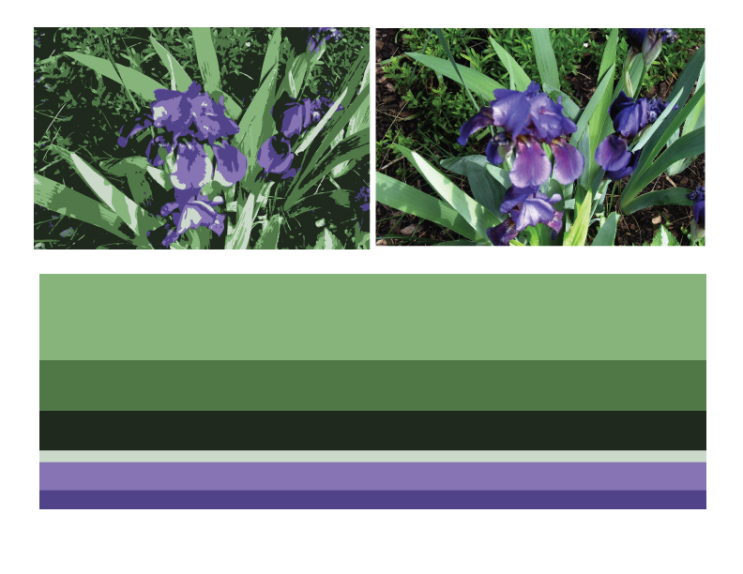

Part III: Creating Mood
Pick four of the following emotions. Type your name and manipulate the typeface, style, size, and color to portray that emotion. Explain why you picked the elements you did.

- Amazement
- Jealousy
- Vengefulness
- Jubilation
- Euphoria
- Relief
- Glee
- Compassion
- Desire
- Lust
- Triumph
- Grumpy
- Passion
- Anger
- Annoyance
- Contempt
- Disgust
- Embarrassment
- Fear
- Worry
- Envy
- Boredom
- Sadness
- Stress
- Amusement
- Delight
- Importance
- Pleasure
- Affection
- Friendliness
- Courage
- Hope
- Pride
- Trust
- Calm
- Relaxed
- Serene
- Interested
- Surprised

