Giuseppe Garibaldi (1807-1882) 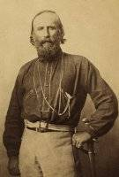
- What age of unification was Garibaldi apart of?
- What other name was Garibaldi referred as with Cavour and Mazzini?
- What legion did Garibaldi form in 1843?
- What was the name of Garibaldi’s Brazilian wife?
- What year did she die?
- What did Garibaldi do once the plot to overthrow the Piedmontese government failed?
- In the early 1830’s he became a part of what movement?
- What was this movement’s main focus?
- What were the “Thousand Red Shirts”?
- Why was Garibaldi significant?

Sources

http://www.ohio.edu/chastain/dh/gari.htm

http://www.reformation.org/garibaldi.html

http://history1800s.about.com/od/giuseppegaribaldi/p/garibaldibio.htm

