PJ



Overview

Self Evaluation & Progress Reports

Logistics

Discussions

Project Revision Form

Global Scholars Day

PJ

Global Connections

PROJECT





Tallwood Global Scholars Day

PJ1

Senior Project Exhibition, held at the Virginia Beach Higher Education Center and titled Tallwood Global Scholars Day, will count as 200 points in the May grade book. Students should think of this display as a precursor to the June presentation and a method of getting prepared for the final evaluation.

As this exhibition is casual (i.e. viewers will be able to see tables, sit and enjoy student made products, such as movies, documentaries, performances, etc), students may be tempted to think that the display should also be casual. However, it is more beneficial to think of the evening as a showcase of the best aspects of the year. When thought of in this light, students have said that TGSD felt like a milestone being met.

Because it is during the busy month of May, and because it is in the evening at an offsite location, it is not mandatory that all students are present. It is highly suggested, of course that students do show up.

What is mandatory, though, is that all students submit work to the event based on the criteria highlighted in the Senior Project Exhibition Rubric. The event will have secret evaluators scoring the exhibitions, so it is important to have the best products on display.

Ideally the event will feed right into the June Presentation where students will already have evidence of the process involved in the Global Connection Seminar provided at the evening and all they need to do is make any necessary improvements to show the judges during the June Presentation.

It is therefore essential to think of this Global Scholars Day as a full year culmination of what was accomplished in this very impressive year.

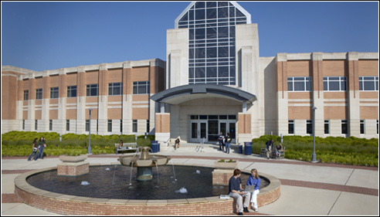

<http://www.odu.edu/ao/vbhec/>

**Senior Project Global Scholars Day Exhibition Evaluation**

**Virginia Beach Higher Education Center**

 Student Name:  ___________________________________

Overall Score: ____________________________________

Overall Comments:

#### 

|  |  |  |  |  |  |
| --- | --- | --- | --- | --- | --- |
| Exhibition Criteria | Needs Developing | Satisfactory Covers Most of Criteria | Acceptable Covers All of Criteria | Exceeds Expectations | Not Applicable (Explain) |
| Growth  You clearly explain your process as well as reflection |  |  |  |  |  |
| Project  You clearly explain the steps of your project as well as your overall goal / mission. |  |  |  |  |  |
| Expertise  Through display of elements of your research, you demonstrate expertise in your topic, supported by a solid foundation of knowledge.  You demonstrate enthusiasm and confidence about material/subject. |  |  |  |  |  |
| Q and A  You answer questions knowledgeably and thoroughly, either through your physical presence or through anticipated questioning in your display. |  |  |  |  |  |
| Message  Your message is clear in the display and viewers can get a balanced view of the background information and your contribution to the issue  You understand the needs and expertise level of your audience. |  |  |  |  |  |
| Visual /Audio/ Oral  Visual/Audio/Oral is interesting and holds attention of audience.  You understand, anticipate, and fulfill your technical / display/ spatial needs.  You successfully use supporting materials to highlight your message. |  |  |  |  |  |

(Adapted from Francis W. Parker Charter School)

|  |
| --- |
| **SENIOR PROJECT OVERVIEW** |

**DIRECTIONS: Explain each area in 35 to 50 words.**

Name: ___________________________________________________

Title of Project: ___________________________________________

PJ2

Title of Research Paper: _____________________________________

Synopsis of Research Paper:

Project Description:

Relationship between Project and Paper:

My background experience in the area:

Special things I’d like judges to consider and look for:

Making Connections Between Project and Paper

Using your own knowledge, the information gathered from the previous two pages, and the email information in the readings, decide on what information goes in what box. Remember your answers very much depend on your question(s). And don’t fall into any traps! Let’s pretend that this is your question:

***To what extent is U.S. involvement with and protection of the Acholi people substantive enough to make real change in the region?***

Now decide up three Focal Points:

1.

2.

3.

Change your Focal Points and you change your arrangement. Essentially, the final box (Good For Both) is the box that will help you explain the connection between project and paper and help guide you in making sure the project is effective to the actually needs (as revealed through research). You can easily use this set up for your own project.

 Good for Both

Sift through the items from Good for Project and Good for Paper to come up with a shortlist here. There is no need to force-fit any item, because this activity is for explanatory purposes. In other words, a few good points on how the research and the project connect are much better than a lot of mediocre ones. This should also assist you in creating a “mission statement” and making really separating your work from that of others.

 Good for Paper

Include items that are relevant to topic, thesis, and or focal points. Always the items should be answering the question. Be careful not to try to fit only items in this box that agree with your presupposed ideas. The thesis should be driven by the items you select, not the other way round.

 Good for Project

Include items that are relevant to topic, thesis, and or focal points. Always the items should be addressing the issue. Be careful not to try to fit only items in this box that agree with your presupposed ideas. The heart of the project should be driven by the items you select, not the other way round.

 Not Good to Include

Sometimes even very interesting or seemingly relevant information doesn’t make the final cut because it doesn’t match the focus of the paper / project. You may need to explain why you didn’t include something in your paper/project…this is called educating your audience.

A Question of Focus

Information from Email from Julie Hill of Outreach Africa: Lost Boys Foundation

|  |  |
| --- | --- |
| NORTH | SOUTH |
| National government ruled by a radical Muslim sect ( the National Islamic Front)  Which wants all Sudanese to become Muslim and adopt Sharia law. | Christian/ Animists who just want everyone to have freedom of religion |
| Arabs who came as traders 100 years ago when Sudan was an English colony.  When the English pulled out they put the Muslim Arabs in charge | Indigenous tribes who had lived there for thousands of years |
| Little oil on Northern land | The South has lots of oil which the Northerners want and are taking |
|  | The tribes have been marginalized with no opportunity to participate in government |
|  |  |

**Why doesn’t the US intervene in the conflicts in Sudan?**

China is the main purchaser of Sudanese Oil. India is the second. The rest of the world boycotts Chinese oil as a matter of conscience because of the genocide in Darfur.

The Sudanese government had China build the oil infrastructure in the South of Sudan and China supplies the troops that guard the oil wells, pipeline, etc.

China also supplies North Sudan with the bombers, helicopter gunships, arms and munitions to carry out the genocide in Darfur. The continuing genocide keeps the oil off the world market (boycotts by the rest of the world), thus lowering oil price for Chinese consumption.

China is the second largest purchaser of US Treasury bills, floating a large part of our debt. If China stopped buying our t-bills, our economy would grind to a halt. If they sold out t-bills, our economy would collapse.

Thus, the US says nothing against China and its perpetration of the genocide in Sudan.

What is the *Call to Action* from all of these facts? How will you accomplish it? Is the action true to the research?

**North vs. Darfur**

The tribes of Darfur adopted Islam in an effort to save themselves from the Radical Islamic Northern government

During the 23 year genocide (“Civil War”) against the South, the tribes of Darfur were co-opted by the Northern Government to help carry out the attacks against the tribes of the South.

Oil has been discovered in the region of Darfur

In the past, a Darfurian was elected Vice President of Sudan and immediately went down in a mysterious air crash. Coincidentally, after the Comprehensive Peace Agreement between the North and the South, a Southerner was made Vice President of Sudan and he, too, went down in a mysterious air crash just 3 weeks after he assumed office.

**Subject:** Today - Call Senators for Sudan

|  |
| --- |
| Members of the Diaspora, the GOSS (Government of South Sudan) Mission and friends of Sudan are meeting with members of the Senate Foreign Relations Committee.  Please support their efforts.    1)       Please call members of the Senate Foreign Relations Committee  2)       Ask **the Committee to hold regular oversight hearings between now and January 2011 on Sudan** to increase engagement by the Administration to (1) ensure that the referenda are held on time, are free and fair, and that the results are respected; and (2) to secure peace, justice and liberty throughout Sudan. |

Unique Juxapositions

Explain how the following can be connected in Project and Paper

And What About These?

<http://www.history.army.mil/books/wot_artwork/wot_artbook.html>

<http://www.cbc.ca/world/story/2010/08/27/kenya-constitution027.html>

[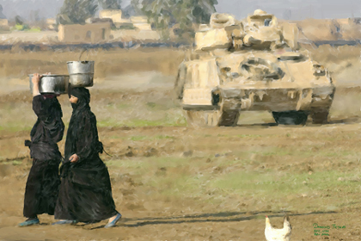](http://www.history.army.mil/books/wot_artwork/images/35b.jpg)

From: Hampton Roads Buy Fresh Buy Local. [www.buylocalhamptonroads.org](http://www.buylocalhamptonroads.org)

“Between 2002 and 2007 about 500,000 acres of farmland in Virginia was lost to development.”

“The food at the supermarket can come from all over the world. The average U.S. produced vegetable travels about 1300 miles from farm to table. Most “fresh” food spends 7-14 days in transit and produce is often picked long before it is ripe.”

How do these increase/decrease the focus of a project? Is it desirable to always connect? Do unique juxtapositions get attention!

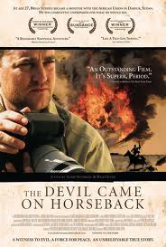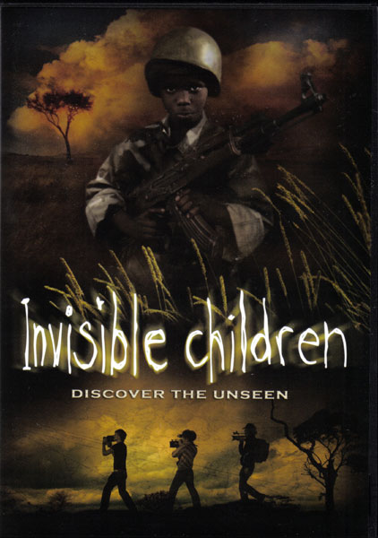<http://www.impawards.com/2007/devil_came_on_horseback.html>

<http://webpages.scu.edu/ftp/mmostamandy/invischild.htm>

<http://subbooks.com/blog/?p=217>

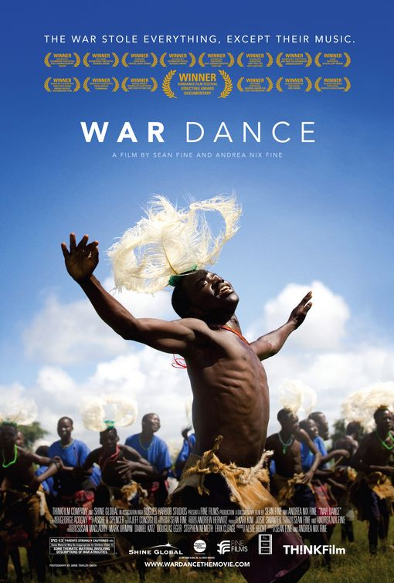 

<http://www.theconns.blogspot.com> <http://energytechstocks.com/wp/?cat=41> <http://www.perfectduluthday.com/2008/04>

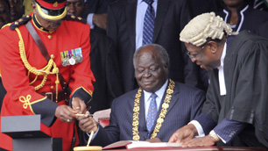

For more aspects check out the following links

<http://www.democraticunderground.com/discuss/duboard.php?az=view_all&address=385x298807>

<http://www.sudantribune.com/spip.php?article33798>

<http://www.epi.org/publications/entry/ib235>

<http://www.youtube.com/watch?v=VW8pPS3juZs>

NOTE: For Raw Footage on the Sudan for purchase from schools, see: <http://www.take2videos.org/LOCALES/2011.html>

CLICK HERE TO WATCH A TRAILER OF “THE DEVIL CAME ON HORSEBACK”

<http://videos.orange.es/video/iLyROoafteTV.html>

CLICK HERE TO WATCH THE FULL VERSION OF THE FILM” INVISIBLE CHILDREN”

<http://video.google.com/videoplay?docid=-6547143034681962841#docid=3166797753930210643>

CLICK HERE TO WATCH THE FULL VERSION OF “WAR DANCE”

[http://video.google.com/videoplay?docid=-6547143034681962841#](http://video.google.com/videoplay?docid=-6547143034681962841)

Matching the content you stumble across, with the direction you are aiming at, can make a paper or project look like a Wordle*. Like this Wordle on the additional examples on possible reasons the Sudan is the way it is today (<http://www.wordle.net/show/wrdl/2348462/Why_Sudan>), project coordinators need to always stay focused on the target…to do so, they need to have a target.

All of the examples in the above Wordle are legitimate, however, only if used correctly. They need to be segregated into useable and unusable, and then sorted into groups. The idea is that the Call to Action should match the research that you’ve done. The two should complement each other.

Create your own Wordle on your project here (it might be hard to save, so just cut and paste the link.

Then in the space provided, fill out the bulls-eye above to match your research and Call to Action. The further away from the center, the less concentrated the target…in other words, if push comes to shove, these are the questions / foci of the project that can be let go. This activity should help you get to the core of what you are set out to accomplish and help you justify why you didn’t go in a particular direction.

*For any interested student who wishes to continue research on this topic, please see the teacher for a start up bibliography.

“A Little Knowledge Is a Dangerous Thing”

Alexander Pope’s quote rings true when considering that the desire to connect points does not equal the right to do so. Explored briefly in the Logical Fallacies section, this idea can lead to traps, but if done correctly, can also lead to questions. And questions lead to truth.

Truth

Questions

Traps

Analyzing the Project Work of Others.

View the following links from a group called “Improv Everywhere” <http://improveverywhere.com/> and discuss in small groups what sort of organization was necessary to achieve the goal. Use this sheet to organize the thoughts from your group for the class discussion.

FROZEN GRAND CENTRAL

<http://www.youtube.com/watch?v=jwMj3PJDxuo>

SPONTANEOUS MUSICAL IN FOOD COURT

<http://www.youtube.com/watch?v=dkYZ6rbPU2M&p=9C5623622606791F&playnext=1>

PJ3

BEST GAME EVER

<http://www.youtube.com/watch?v=_Nbkbss7i5s&NR=1>

HUMAN MIRROR

<http://www.youtube.com/watch?v=9MBBr-a2KnM&NR=1>

MP3 EXPERIMENT 6

<http://www.youtube.com/watch?v=x1O1rv7vDsE&feature=player_embedded>

**Class Project “Drag Drawers”**

*Topic / Event:*

*____________________________*

*Goal:*

*____________________________*

*Date:/ Completion Date*

*___________________________*

*Venue:*

*____________________________*

*Assistance Needed:*

*____________________________*

*Population Served:*

*____________________________*

*Fundraising Considerations*

*____________________________*

*Paperwork Completion/*

*Administrative Approval*

*____________________________*

*Before Event*

*____________________________*

*Day of Event*

*____________________________*

*After Event*

*____________________________*

**(Autumn and Spring)**

6

Group 4 5

Group 2 4

1

2

3

Figuring Out the Logistics

For his project senior David Thomas (2010) created an Economic Mock Trial to Teach the Public about Bank Failures.

His Research Question was “How can bank failures be justified to the public?”

To do the mock trail, he created a script, which is located in the readings.

Chart out the logistics on how to make this event spectacular. Be as specific as possible.

|  |  |
| --- | --- |
| Before |  |
| During |  |
| After |  |

|  |
| --- |
| **Directions:**  Utilize this worksheet to help evaluate yourself and your project. Be as complete and descriptive as possible. Be sure to give a typed clear description and account for all twelve items on the self-evaluation. Turn this in with your evidence of progress and your final project rubric grading. |

Self Evaluations

Name __________________ Project Start Date _____________________

Title of Project __________________ Project Completion Date ____________________

1. In 40 words or more describe your project and the steps you performed to complete it. What did you produce or perform?
2. In at least 40 words explain how the project challenged you, and what sort of time challenges and resource problems did you encounter.
3. List and then describe 5-8 fundamental ideas/concepts/skills of your project, which you learned during your project.
4. List and describe 5-8 problems you encountered in your project, and briefly describe how you solved each.

PJ4

1. Outline the process hours spent in completing the project.
2. Estimated total hours spent on project:_______

{Should match those detailed in Progress Report}

1. Estimated total steps involved in your project: ________

*Modify number of steps to fit your project.*

**Steps Involved Hours Date Completed**

**Step 1: __________________________________ _______ ___________________**

**Step 2: __________________________________ _______ ___________________**

**Step 3: __________________________________ _______ ___________________**

1. List materials used:
2. List **all** people who helped you on the project and briefly describe the help given.
3. How does your completed project compare to the picture you had in mind when you started the project?
4. If given the opportunity, what would you do differently now that you speak from experience?
5. Now that the project is completed, explain/describe the stretch or challenge you encountered/experienced.
6. Beyond the project itself, what did you learn about yourself?
7. What grade would you give yourself on the project? Justify the evaluation of your grade in at least 25 words.

Grade: ____________

Justification:

In self evaluation, honesty goes a long way. When a project “fails, even in your own mind, remember that this is a greater opportunity to reflect. Find some reflections included on “Pitfalls of the Senior Project” on the Wikispace. This should ensure you that you are not alone in your frustrations. When you reflect upon the downs more than the ups of the project, be sure to season your self evaluation with a comparative reality. Step back and look at what you really accomplished, you will be amazed.

Likewise, when a project “succeeds”, be skeptical. Does this suggest your sights were not high enough or that you are not honestly assessing the weight of the issue, cultural dimension being researched. As every scholar knows, the deeper one goes, the more one realizes they are surrounded by the unknown. Measure your success sparingly and with an ounce of precautionary humility.

Sample Answers to Project Evaluation Worksheet

A sampling of answers to the Project Evaluation Worksheet from Alisia Spielvogel, recipient of the 2009 Scholarship for Outstanding Senior Project (Autumn). Her project was to create a panel discussion that explored the balancing act of being prepared against threats of extremist Islamic terrorists, whilst maintaining a level of tolerance and understanding for the Muslim faith.

This panel, led by Alisia’s role as moderator and facilitator, was made up of experts from various branches of international militaries. The event started off with a viewing a portion of a controversial film depicting Muslims as terrorists, then moved on to short presentations/reactions by the panel, and finished with Alisia facilitating a question and answer period between audience and the panel. Prior to the event, she spent a great deal of preparation creating meaningful questions for her panel and her audience members, many of which she used as prompts to begin the discussion for the evening.

Notice in the self evaluation that there are complete sentences with logical explanations that show growth, show rationale for doing something in a certain way, as well as highlight innovative solutions to a problem. These are only small samples and students should complete the evaluation to the level that is required to fully answer the question.

***From Question 3***

***Example from Project on Global Terrorism***

**Idea/Concept/Skill Explanation** (how you learned it)

*Islamic Terrorism In order to present an objective study on Islamic Terrorism,*

*I had to define terrorism and distinguish between Muslim*

*terrorists and Muslim pacifists*

***From Question 4***

***Example from Project on Islamic Terrorism***

**Problem Explanation**

*Research Many of the cases I was looking for were not accessible through the schools Internet service, therefore I had to use other resources.*

***From Question 7***

***Example***

*Ed Davis Project Consultant; he let me have access to special cases documented by Amnesty International which the popular media had not yet published or broadcasted.*

|  |
| --- |
| **SAMPLE PROGRESS REPORT** |

**TO:**  Senior Project Grader

**FROM:** John Doe

**DATE:** February 5, 2006

**SUBJECT:** Progress Report 4: Retexturing Walls

**PREVIOUS BACKGROUND:** Set up appointment with contractor and purchase supplies, prep walls and tape off windows.

**TIME FRAME:** December 8, 2005- December 23, 2005 **HOURS SPENT:** 9

**WORK COMPLETED**

* *Discuss the items worked on or completed during this time frame.*

**WORK SCHEDULED**

* *Discuss what you plan on working next.*

**PROBLEMS ENCOUNTERED**

* *What problems/difficulties did you encounter?*
* *How did you handle them?*

**REFLECTIVE JOURNAL**

* *Journals need to be at least half a page.*
* *Talk about details of the process – task the Senior Project Defense Panel need to know about in order to understand the amount of work you put into the project.*

**USE AS MUCH SPACE AS NECESSARY FOR EACH ENTRY**

|  |
| --- |
| **PROJECT REVISION FORM** |

|  |
| --- |
| **To the student**: Provide the information requested, a new proposal with highlighted changes, and sign on the appropriate line. |

Name Email:

Class Schedule

Project Title

Advisor Room #

Project Consultant Phone #

Explain the changes or alterations you are requesting.

For what reason(s) are these changes necessary?

How will these changes affect the outcome, challenge and time initially put forth in your proposal?

PJ5

Student Signature Date

|  |
| --- |
|  |

Revision to project: Approved Declined

Reason for Decision

Signature of Project Coordinator Date

Topic Discussion Session

Use this sheet which is sent out to the Topic Discussion Leaders as a checklist.

|  |  |  |  |  |  |  |  |  |  |
| --- | --- | --- | --- | --- | --- | --- | --- | --- | --- |
| 1 | 2 | 3 | 4 | 5 | 6 | 7 | 8 | 9 | 10 |

Students should have included for your perusal the following in a one sheet document

1. Finished Proposal

    2. Rough Draft Abstract

    3. Research paper to date (not due until end of January)

    4. Unanswerable Question

    5. Proposed sections and focal points

    6. Thesis statement to date (might be revised up to end of January)

    7. Mentor name and contact

    8. Research Specialist name

    9. Number of sources to date

    10. Any project work they wish to share (project due in May)

***Note: Since the Topic Discussions occur after the Proposal stage, there should be little, if any alterations to the proposal. However, students should be aware that the remaining items most likely will be rough draft (depending how close the project implementation is to the Topic Discussion*).**

PJ6

*In the Topic Discussion Sessions, held after the proposal is accepted and before the paper is due, administrators sit one on one with the student to draw out a conversation. This is to be a casual conversation in form, but an intense conversation in content. In other words, this is an essential step in the student’s evolution towards expertise and can be seen as a harbinger of the future. Most or all of the skills needed to succeed at other elements of the seminar are harvested and nurtured here. More importantly though, as a discussion, it is a way in which ideas can be mined from other members of the Tallwood family, students can be seen for the scholars that they are, and the proverbial community can raise the proverbial child. Students, therefore should be prepared but relaxed at these sessions. For a full sample of a Topic Discussion Packet, see the readings section, where Harley Galaty’s (2010) work is on display. To what extent do you think this represented the final project?*

The Project Abstract: Keeping It Fresh

By the time the Panel Evaluation rolls around in June, it may have been a long time since the student has completed the paper, the project, or even the Tallwood Board Presentation. Therefore, to keep it “fresh” in the minds of the student who will be presenting to the panel judges, students are asked to do occasional progress reports, updates, and have the opportunity to revise work for a better grade. Students should refer to the scoring and grading guide in this manual for more details.

From another perspective, though, the projects and papers must be fresh in the eyes of the judges. Remember, this is the first time many judges have seen these ideas presented. Therefore, students are asked to write abstracts for the judges’ perusal.

One may look something like the examples below:

Notice the descriptions are not long, but rather give the judges something to think about and to prepare as they get ready for the judging round. In this way, students who put effort in their abstracts can actually influence the questions that the judges may create.

Highlighting areas of expertise in the abstract, rather than areas of struggle can help calm some of the anxiety of the year, because it directs the judges to successes rather than pitfalls. That’s not to say that students should not be ready to explain or reflect upon areas that went astray. An honest assessment with reflection on what would be done differently shows growth and maturity. A glossing over the bad to look good is unrealistic and will easily become transparent.

The box below, by 2010 student Zach Dickerson, gives more or less equal treatment to the research paper and the project, though the structures of both are different. In the third set, three questions provided for the judges to use at their discretion is yet another way to reduce the nervousness of the evaluation.

*“No artist is ahead of his time. He is his time.”*

*Martha Graham*

|  |  |  |  |
| --- | --- | --- | --- |
| **310**  **Zach Dickerson** | **310 Why is the Arab culture so misunderstood?** | **-Why should we care about attitudes towards Arabs?**  **-Are we moving away from or towards a better understanding? Why is this the case?**  **-How can myths be debunked.** | **310 My main goal was to help reduce/eliminate the prejudices and negative opinions that many Americans have of Arab people. I started an afterschool program at Malibu Elementary School in order to help immerse young students in the Arab culture, so they won’t misunderstand it when they grow older. I included activities such as language learning, Arab games, song and dance, and arts and crafts. The students were very open to these new experiences, and really enjoyed getting to know more about the “mysterious” Arab culture. They, now that they understand another culture, hopefully will not have prejudices in the future.** |

**Project Discussion Cubes**

Fundraising Based Project

Tallwood Based Project

Community Service Based Projects

Media Based Projects

Project Notes for your project

-no two projects on the same day, project dates are reserved on a sign up basis,

must be based on accepted proposal, projects must be completed

-

-

-

-

-

-

-

-

-

**Project Discussion Cubes**

Needs Assessment

Marketing and Creating a Face

Core Group

Scheduling Considerations

Project Notes for your project

-no two projects on the same day, project dates are reserved on a sign up basis,

must be based on accepted proposal, projects must be completed

-

-

-

-

-

-

-

-

-

Donor Fatigue

See readings in reading section to use in the discussion.

Giving Interviews about Your Project

See readings in the Readings section for more information

From <http://www.unison.org.uk/acrobat/B1865.pdf>

**How to give a successful interview to a newspaper**

Giving a successful interview to a newspaper depends on a range of factors,

some of which are not under your control. But with good planning and

anticipation you can learn to use local and national newspapers successfully.

**Speaking with authority**

Make sure that the most appropriate person gives the interview and that they are

speaking with the authority of the branch. After all, you are not being asked for a

personal opinion, but UNISON Anywhere Branch's view. If you are asked to

comment on a UNISON policy issue, do check first with your regional office.

**Preparation**

Preparation is the key to a good interview, being on the ball, but knowing how to

stall if necessary. There should be no surprise if you have just sent out a press

release, for instance. You should be expecting a follow up.

**Out of the blue**

Circumstances can vary widely. The most likely situation is when you are

telephoned by a journalist. But you could also be interviewed face to face or you

may be stopped on the way out of a meeting. Don't be thrown: A reporter will ring

up out of the blue, want to talk to you right now and say it is urgent with a

deadline in 10 minutes. Regardless, insist that you have someone with you and

you'll ring back. This gives you a few minutes to think through exactly what you

want to say or to take advice. If there is media interest in negotiations remember

to have a sound bite prepared before you leave the building.

**Setting the agenda**

If you want to publicise something make sure you can describe it vividly as a

news item. The reporter will want a strong quote that the introduction to the story

and the headline can be taken from. Remember, most reporters are eager to fill

their pages–if you can give them a story and some quotes, they'll often use it.

You can always repeat the form of words that you have chosen.

For example: *'I would say that the trust chief executive has behaved unfairly. No, I would not say he is lying, he has behaved unfairly. He has treated staff in an unfair way.'*

It can be vital to get your own shade of meaning over and not have the

newspaper choose how you are saying things. Don't worry about repeating

yourself–it's one way to make sure your message gets across.

**Handling bad publicity**

If a newspaper is chasing a story which you would rather discourage, beware the

hidden question. There may be a lengthy interview about fairly commonplace

matters with a key question thrown in near the end. Be on your guard. And

remember you can always refuse to comment.

**Off the record**

Learn the rules of 'off the record'. It doesn't mean the information you give won't

be used. It means that the journalist will use the information you have supplied

but it will not be attributed to you. An opinion that you express will be given but

the author of the opinion not named ('One union official said'). Never, never,

never conduct an interview and at the end say '*This isn't for publication is it*?'

There is no other earthly reason why a journalist should be talking to you.

**Getting your quotes right**

Newspapers will resist letting you see the story in advance and for a news story

near to deadline this is impractical. But for a feature, for instance, being prepared

a week in advance, ask the reporter to fax back the quotes which he or she has

recorded you saying. Above all keep a tight hold of the agenda of the interview

and be prepared to disappoint a journalist who is encouraging you to confirm

some sensational opinion which you are not quite happy with.

**Enjoy yourself!**

Once you've spoken to the papers and seen your words in print a couple of

times, you may even start to enjoy it. After all, most reporters you speak to aren't

Jeremy Paxman! And using your local press can be a deciding factor in pay talks

or local campaigns. So learn to relax and enjoy yourself.

Should you get an interview, you need to be prepared. Use the table below (intentionally left blank so that you can set your own criteria) to pinpoint highlights you’d like to include in an interview. This chart may need updates as you progress through the seminar. Two boxes have been done for you.

|  |  |  |  |  |
| --- | --- | --- | --- | --- |
|  |  |  |  |  |
|  |  |  | Contacted THS media liaison who will help set up interview |  |
|  | Mention this is Senior Project. Give details of THS. |  |  |  |
|  |  |  |  |  |